
Proof of concept for Chat application
Revision History
Version | Author | Date | Remarks
1.0 | Suraj P | 12 Oct 2018 | Created

Table of Contents
1 Summary 3
2 “Proof of Concept” Application 3
Goals 3
Chat App Architecture 4
Technology 4
Task and estimates 5

Summary

There are 2 major protocols we can use to implement a chat application. They are
- Using XMPP protocol
- Using WebSocket protocol

We had an initial study on both the protocols and found WebSocket would be more appropriate for our application as:
- High-speed data exchange capacity
- Persistent channels of communication
- Unlimited open sessions one can run at any time

As it is a not a small application, we would to develop this application in two phases as:
- Phase-1: A simple “Proof of concept” application
- Phase-2: The actual application

“Proof of Concept” Application

Goals
- The purpose of developing the PoC is to make sure the following targets are smoothly achieved using the WebSocket communication technology.
- Chat messages will be delivered to the receiver without delay
- Able to send and receive voice messages without delay and the receiver should be able play the audio
- Able to convert voice to Japanese text messages and send to the receiver
- The application should be able to scale up to any number of concurrent users
- Support attachments. Maximum supported attachment file size will be decided based on the study.
- In Online mode, able to send and receive messages from iOS Chat without delay.
- In Offline mode, able to browse messages stored locally in iOS Chat app.
- Security considerations, to be implemented and tested based on the requirement

Chat App Architecture

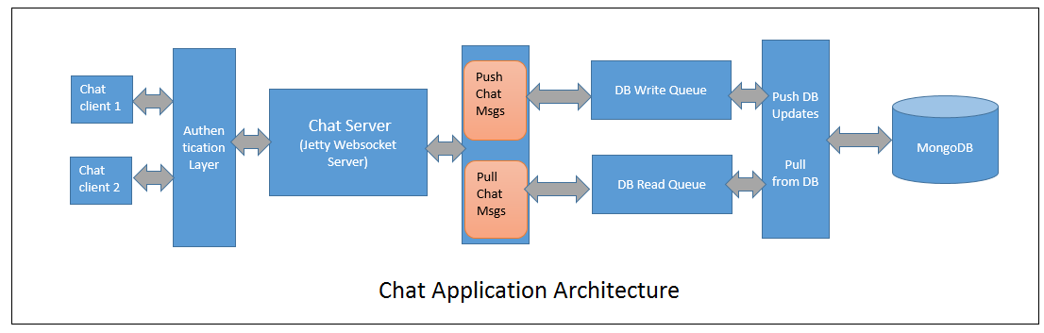

Technology
- Jetty WebSocket
- Mongo DB
- Any appropriate Queue Server
- Java
- Appropriate client-side technology

Jetty is a Java HTTP (Web) server, provides a powerful event driven API based on WebSocket Messages, for both server and client use of WebSocket.
Mongo DB is preferred to any other RDBMS, as it has:
- High writing Speed
- Huge Database scaling capacity
- Document-based query language that’s nearly as powerful as SQL
- High availability

Chat Server will be embedded Jetty WebSocket server with custom code for authentication, and chat message transactions. The chat data will be persisted into the NoSQL, MongoDB database.
Chat Client has two variants, a web client running in browser and an iOS chat app.

Task and estimates

Phase I - Tasks | Estimate in Days
1. Chat server development (Jetty WebSocket server)
a. Identify & develop Chat server | 7
b. Authentication mechanism | 2
2. Web chat client development
a. Voice to text conversion | 4
b. Identify supported browsers & its version | 3
c. Send & receive audio messages | 7
d. Identify & set maximum attachment size in a chat message | 3
e. Identify & set maximum number of characters in a chat message | 2
3. Identify and develop the Database (Mongo DB) for Chat application | 2
4. Testing the identified database for Chat application | 4
5. Identify the Maximum number of concurrent users supported | 4
6. Decide the security mechanism for communication | 4
7. iOS chat client communication with WebSocket server | 4
8. iOS chat offline & online database support | 5
9. Identify & configure Queuing Server for scaling | 4
TOTAL | 55

TOTAL EFFORT ESTIMATE FOR PHASE-I 2.7 Man months

